Burscough Family Practice:
The General Practice Assessment Survey 2013-2014

As part of our aim to make Burscough Family Practice as efficient as possible with the services that we offer our patients, we recently conducted our annual patient survey here at the surgery. The aim of this survey was to gather feedback and opinions from our patients in order to assess the quality of service that we are currently providing here at the practice. We also wanted to identify areas in which we were excelling and also pick out any areas which patients felt we could improve upon.
The survey was anonymous and the questions were designed to ensure that everybody completing the survey could provide their full, honest opinion for all different aspects of the surgery.
The survey was posted onto our website (www.burscoughfamilypractice.co.cuk) and initially, we sent an email out to the 87 email addresses’ of the members of the Virtual Patient Participation Group that we hold on record inviting them to take part in the survey:
“Dear Patient,
Thank you for participating in last year’s General Practice Assessment Survey.
We would like to invite you to take part in this year’s survey. You can find the survey by visiting our website (www.burscoughfamilypractice.co.uk) and clicking on the link to the Patient Participation Group on the left hand side of the page. Here you will find the option to take this year’s survey. Alternatively, there is also an option to take part in our survey on the homepage.
We look forward to hearing from you.
The Practice Team”
In addition to this, all patients attending the surgery in October/November 2013 were given the opportunity to fill in the survey in the surgery itself, or alternatively online at a later date.
We had 84 responses in total to our survey and we discovered that distributing the survey at Reception was the most effective way to gain responses, with over 90% of our responses coming from patients attending the surgery. All of the survey responses were entered into a database to generate the results.
The Practice has a total population of 2590 patients; of which 1352 are male patients and 1238 are female patients. The Practice has a generally older patient population along with some younger patients. In general, the responses to our survey reflected this.
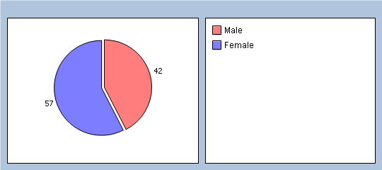
GENDER

AGE
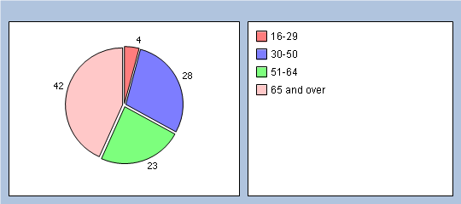

ETHNICITY

JOB STATUS
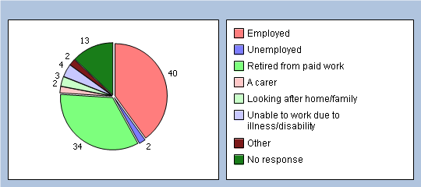

Access:
Only 8% of patients felt that it was not very easy to get through to someone at the Practice on the phone, with 90% finding it either very or fairly easy to get through to us on the phone. For those patients telephoning the practice, 54% said that their queries were dealt with very well and 28% felt that they were dealt with exceptionally! 30% of patient’s haven’t tried to speak to a doctor or nurse on the phone, but for those who have 54% felt like it was very or fairly easy to do so!

Appointments:
Around half of the patient’s completing the survey said they were seen either the same day they requested an appointment or the next day, resulting in a total of 86% of patients being seen within 4 days of requesting an appointment. For patients who need to see a GP urgently, 61% of patients felt that they could normally be seen on the same day, 14% felt they were able to be seen on the same day some of the time and only 8% felt as though they couldn’t. The rest of the patient’s had never needed to see a doctor on the same day.
38% of patients felt that it was very easy to book appointments ahead in the Practice and 34% felt as though it was fairly easy to book appointments ahead in the Practice. From the results, we discovered that the majority of patients (88%) book their appointments over the phone and that booking over the telephone is generally the preferred method of booking appointments (86%).
Quality of Care:
Waiting times for both the GP and the Practice Nurse/Healthcare Assistant were pleasing as the majority of patients only had to wait 5-10 minutes for their appointment’s with both the GP (61%) and our Practice Nurse/Healthcare Assistant (51%).
The aspects of the quality of service provided by the GP were rated excellent or very good by the vast majority of patients, with 84% of patients having confidence and trust in our GP. Nobody said they did not have confidence and trust in our GP.
The same can be said for our Practice Nurse and Healthcare Assistant, who received responses of very good and excellent in all aspects of the quality of service they provide and 77% of patients had confidence and trust in the Practice Nurse and the Healthcare Assistant.
Overall, the majority patient’s described their experience of the surgery as excellent (42%) or very good (33%) with not one person describing their experience as poor!
Opening Hours
The majority of patients were happy with our opening hours and felt that the opening times were convenient to them. Our current opening hours are as follows:
Monday: 8am till 6:30pm
Tuesday: 8am till 6:30pm
Wednesday: 8am till 6:30pm
Thursday: 8am till 12pm
Friday: 8am till 6:30pm

For those patients who in their feedback felt that our opening times were not convenient for them, we as a Practice are going to consider any future changes with regards to the responses to the surgery.

We would like to thank everyone who took part in this year’s survey and we hope that you will also take part in our future surveys as it is the opinions of our patients which are helping us every year to identify the areas in which we can continue to improve. Having said that, we are very happy with the feedback we have received from the survey responses this year and we hope to continue providing a service that all our patients are happy with!
The Practice Team.

